Conference on Investment in Laos, Cambodia and Myanmar
On May 19th the European Chambers of Laos, Cambodia and Myanmar together with the regional law firm DFDL organised an investment conference in Bangkok.
The event, which took place in the Dusit Thani Hotel, was attended by about 60 business people and gave an overview of the economic, legal and tax situation in the three countries.
The situation in Laos was explained by Dr. Ramon Bruesseler, Executive Director of ECCIL, and Mr. Vinay Ahuja, Senior Regional Advisor, DFDL. Cambodia was presented by Ms. Ratana Phurik-Callebaut, Executive Director of Eurocham Cambodia, and Mr. Clint O’Connell, Senior Director, Head of Cambodia Tax Practice, and Myanmar by Ms. Sylvie Garoia, Business Development Manager of Eurocham Myanmar, and Mr. William D. Greenlee, Jr., Partner and Managing Director, DFDL Myanmar.
Mr. Jack Sheehan, Tax Partner, DFDL, presented case studies on how to structure investments into the three countries.
Last year the three chambers started conducting joint presentations with the target of reaching a wider audience and to better enable the audience to make comparisons between the countries so that business decisions could be made based on comprehensive as well as comparative information.

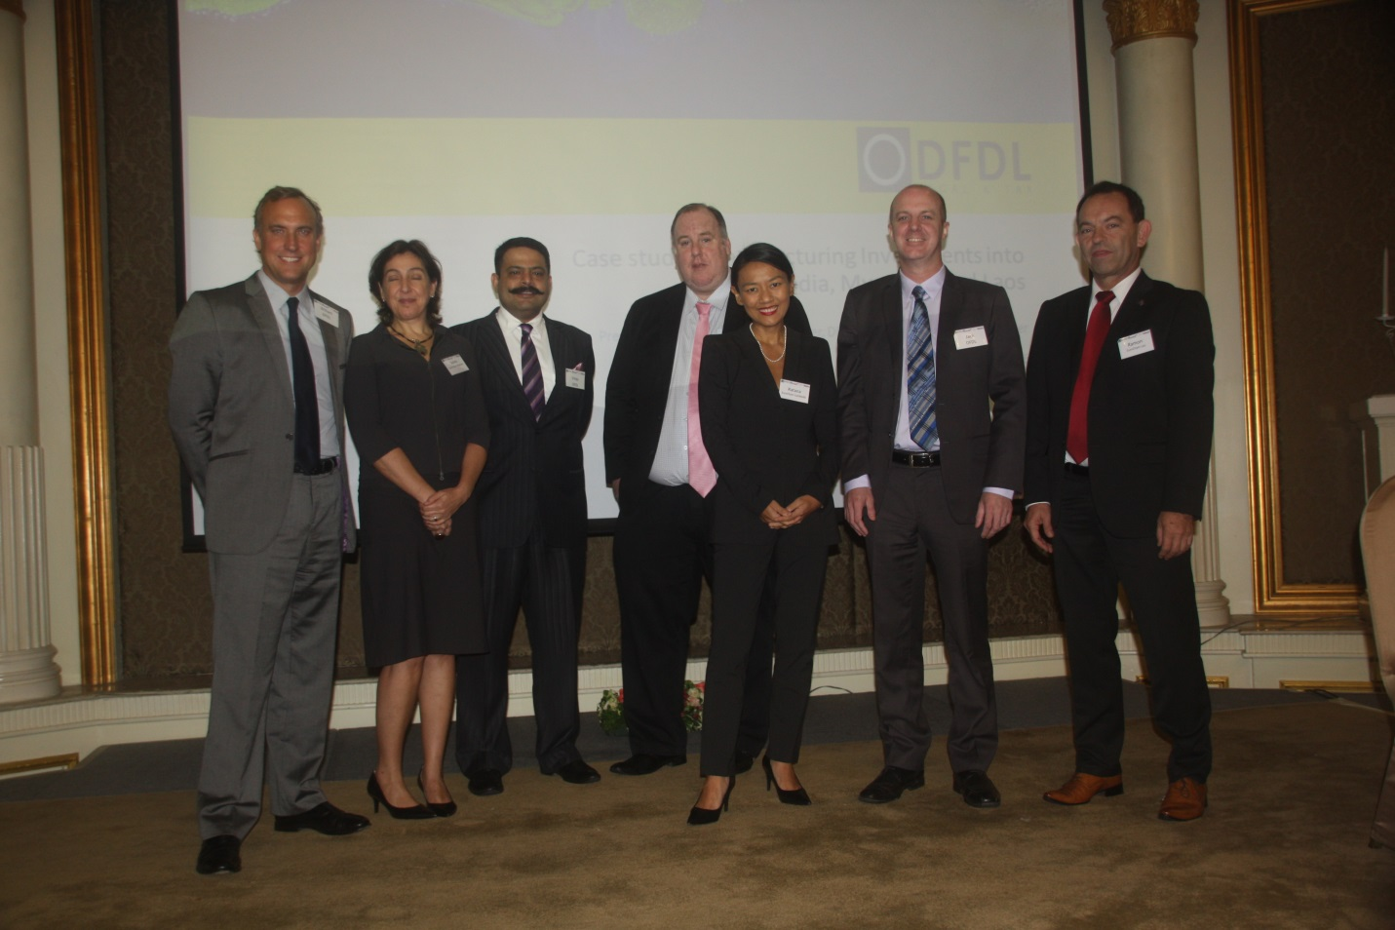
Speakers at the conference (from left to right): William D. Greenlee, Sophia Garoia, Vinay Ahuja, Clint O’Connell, Ratana Phurik-Callebaut, Jack Sheehan, Dr. Ramon Bruesseler.

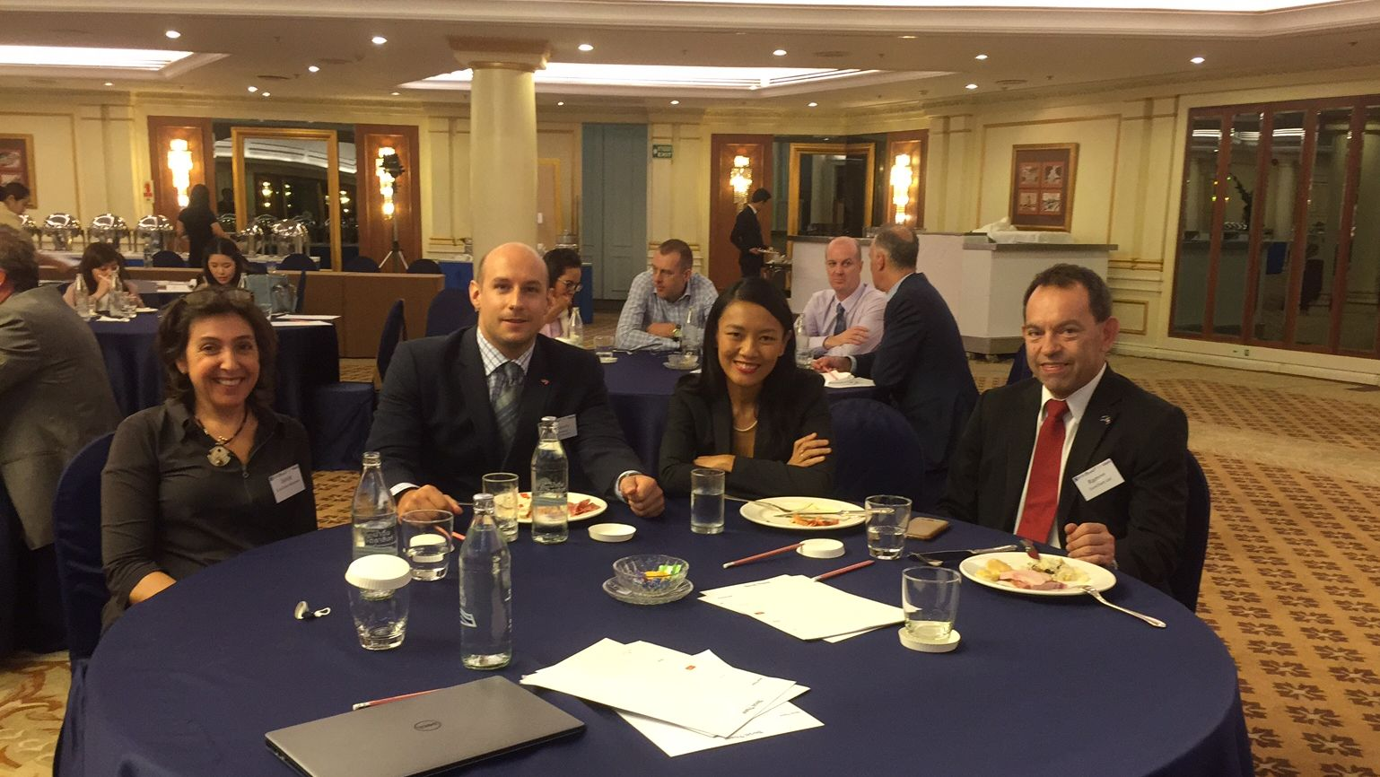
Representatives of the European Chambers of Myanmar, Cambodia and Laos together with Mr. Stephan Spazier, Deputy Economics Delegate of Austria to Thailand.

