Invitation to the
General Assembly of ECCIL and consecutive networking function on June 6th 2019

Dear member of ECCIL,

We hereby invite you to our General Assembly and the consecutive Networking Reception on:
Thursday, June 6th 2019, 17:30 in RETRO Restaurant (Oupmoung Village, Sikhottabong District, 0102 Unit)

The agenda is attached.

In the General Assembly we will present the financial report and the activity report for 2018 as well as the activity plan and the budget for 2019. There will also be the election of a new Executive Committee.
You find a link to a map with the location of the restaurant here.

The General Assembly will be followed by a Networking Reception for members only to which you are of course invited.

If you are an ordinary member of ECCIL and you want to become a member of the Executive Committee of the chamber please fill out the attached form and send it together with the documents mentioned therein to our Executive Director, Dr. Ramon Bruesseler (Ramon.Bruesseler@eccil.org) not later than May 31st 2019. Please note that every candidacy has to be seconded/supported by an ordinary member of ECCIL other than the candidate himself.

In case you will participate in the General Assembly, please fill in the attached registration from and send it back to Mr. Soulath Damrongphol (soulath.damrongphol@eccil.org). For catering and organizational purposes we would appreciate if you could register not later than May 31st 2019.

We very much encourage you to participate personally in our General Assembly.
However, in case you cannot come – please name in writing a proxy (template attached) and notify us under soulath.damrongphol@eccil.org. Please note: only an ordinary member should become a proxy and one person should not be the proxy for more than three members. We therefore ask you to get in touch with the person you would like to be your proxy and get his prior consent.

Kind regards
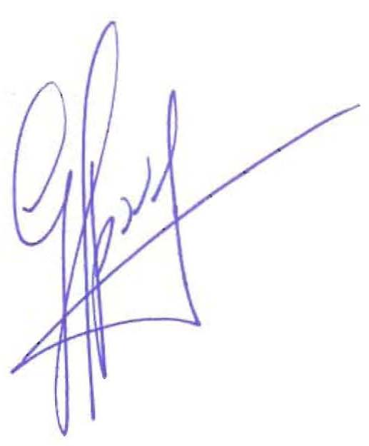
Guy Apovy
President

