European Food Festival Saturday May 7th 2016

The fifth European Food Festival was once again held in the parking area beside the National Culture Hall. Throughout the day a large crowd of people, sometimes numbering as many as a thousand, braved the early sweltering conditions to enjoy the wide variety of exceptional food and beverages on offer.

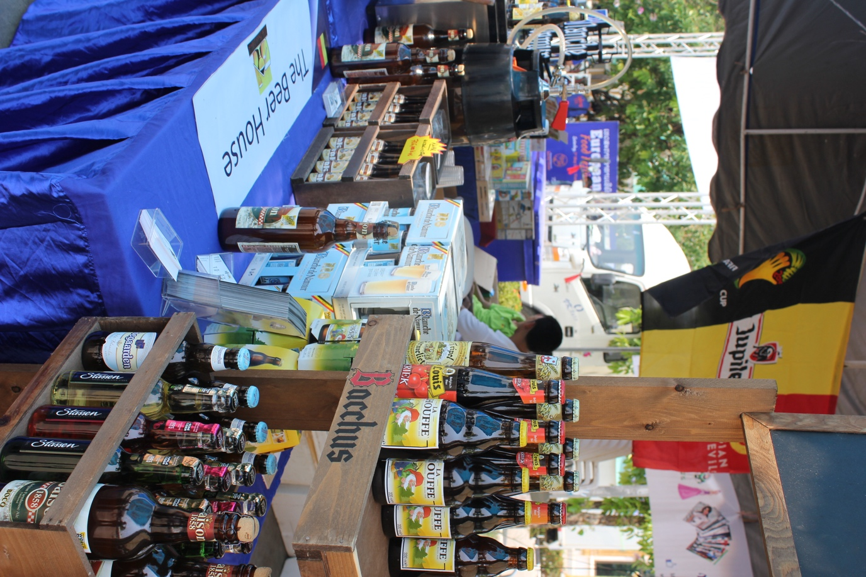

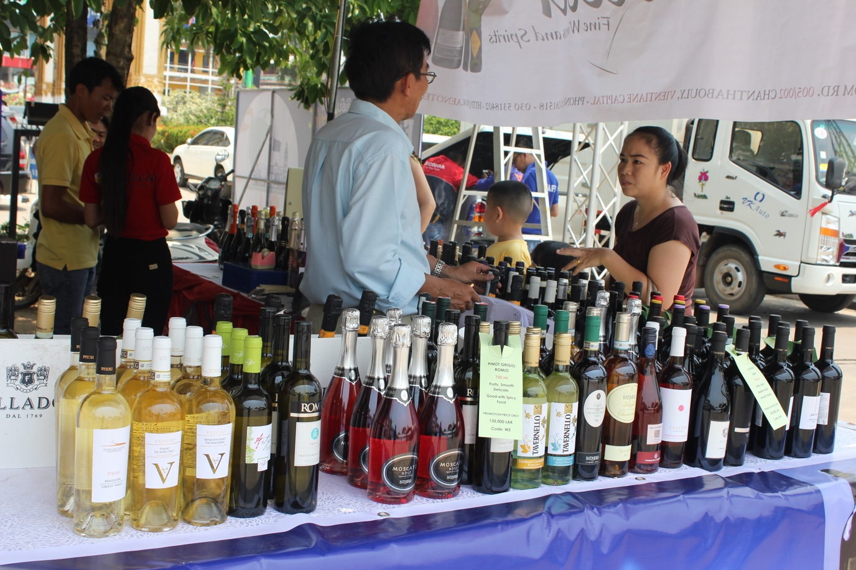

From the crisp ciders and beers of Northern Europe to the mellow and mature flavours of the wines from the South, the wide range of drinks available kept the visitor well hydrated – most necessary under the scorching conditions.

Catering to the appetites of those attending the 24 stallholders, representing some of the more popular restaurants in Vientiane, laid on a big spread of dishes from various parts of Europe, from special German sausages to French delicacies and Italian favourites. All tastes and preferences were well satisfied.

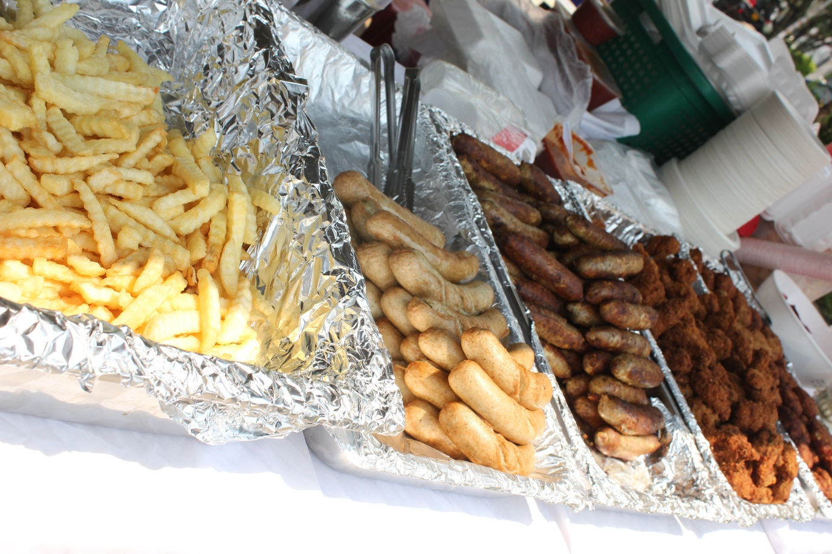

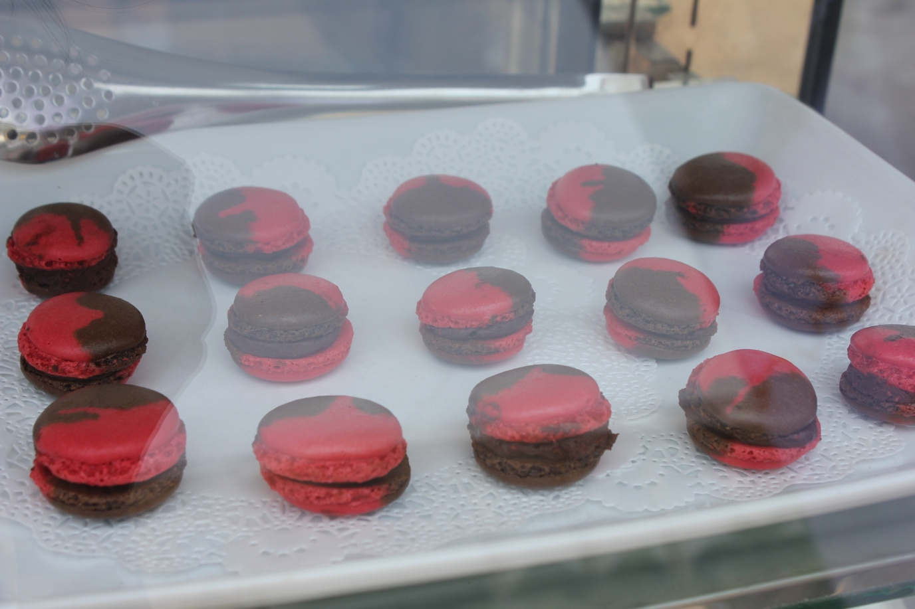

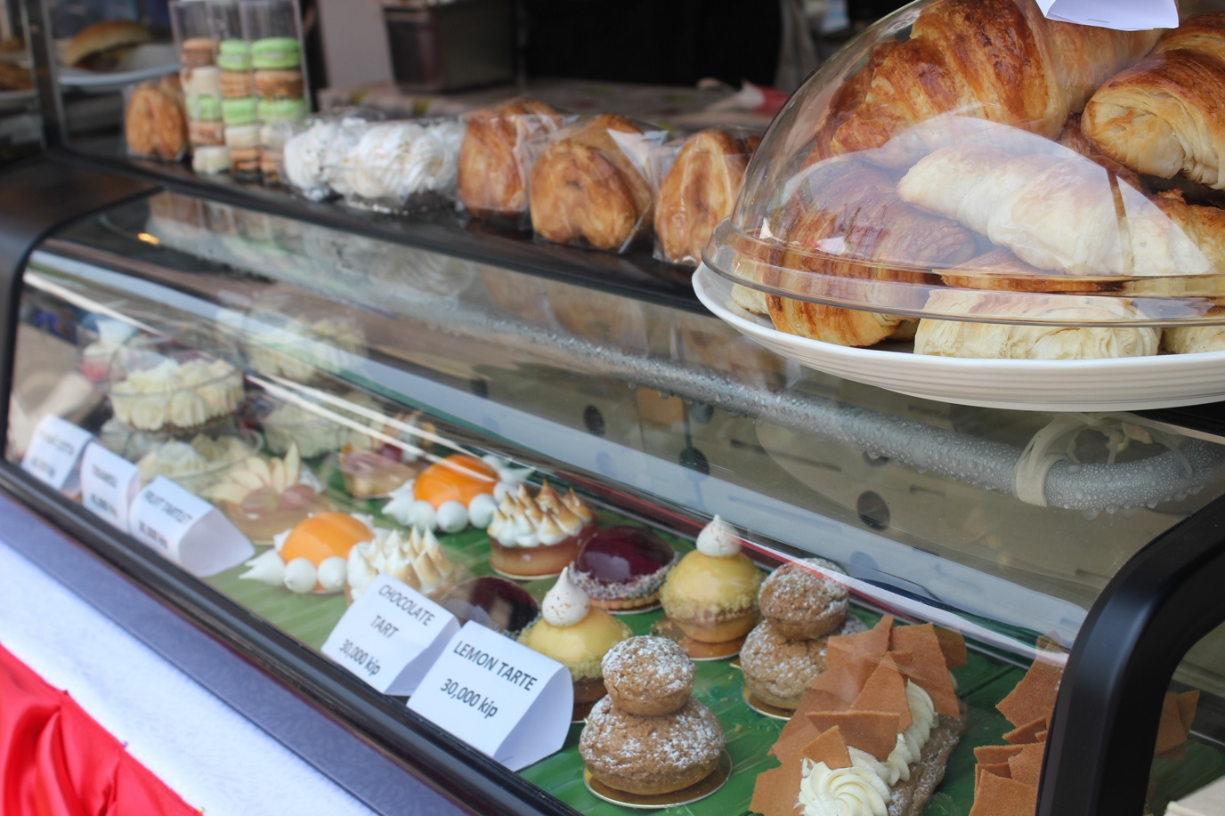

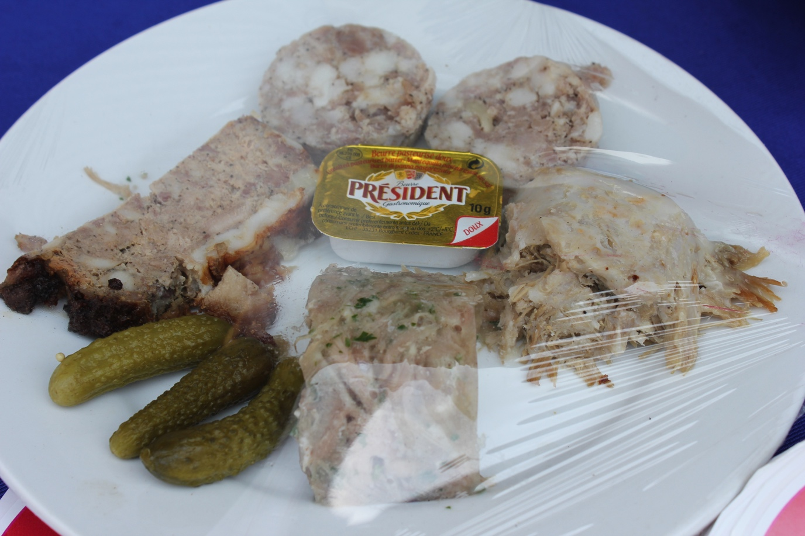

Once the appetites were sated and thirsts quenched it was time to get on with the main purpose of the day – having fun!

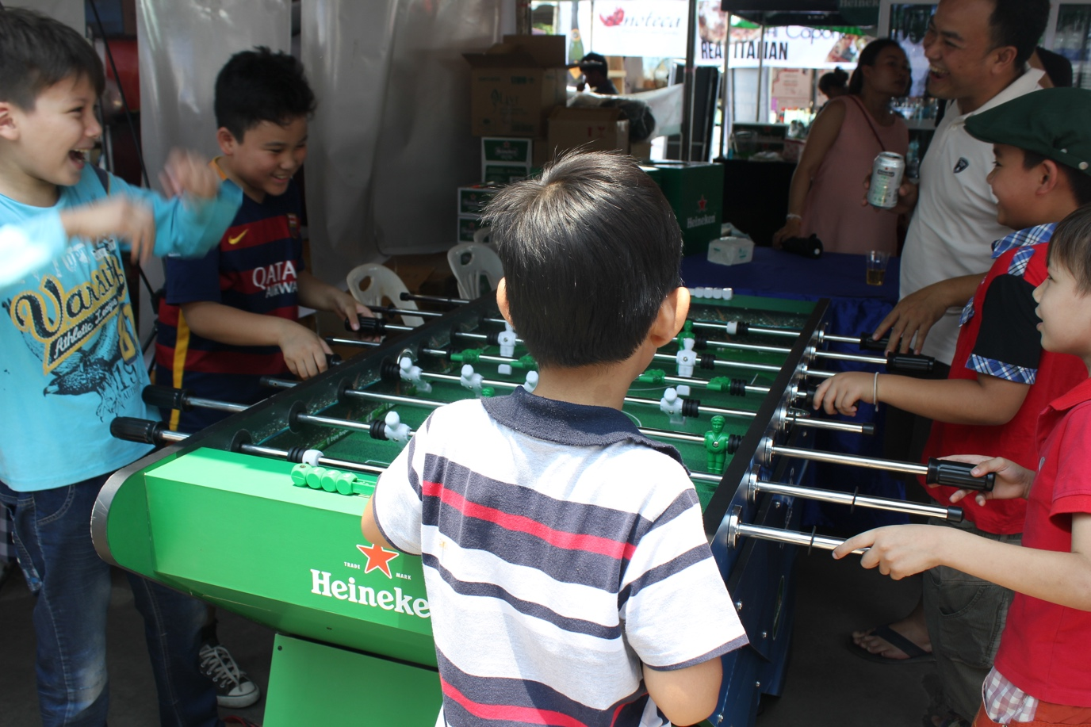

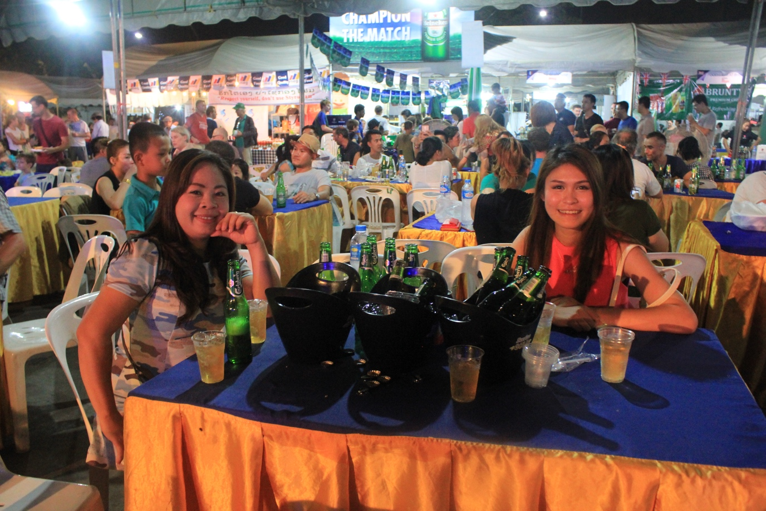

The evenings festivities began with a welcoming speech from EU Charge d’Affairs Michel Goffin with a reply of thanks from ECCIL Executive Director Ramon Bruesseler.
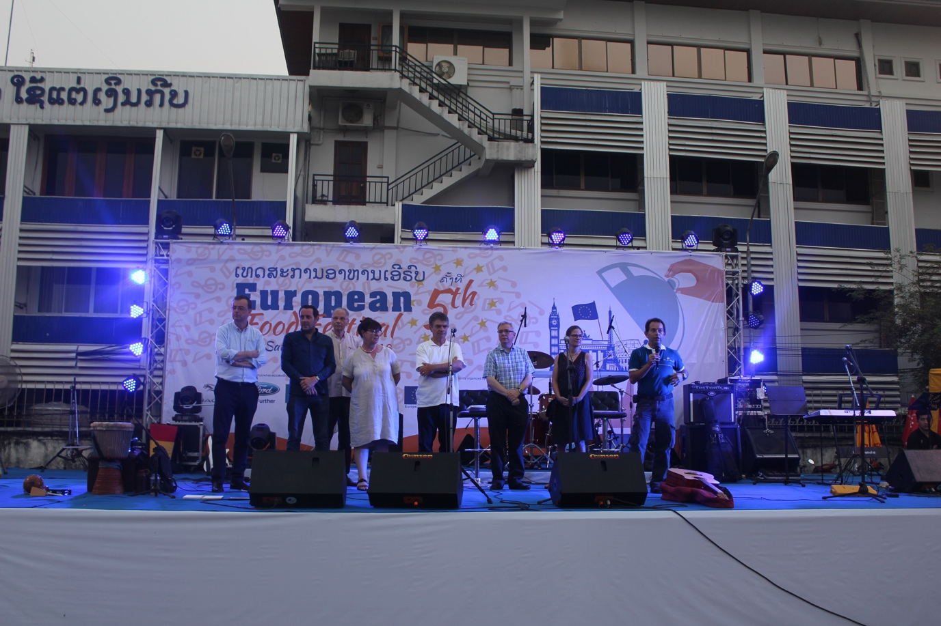

As the sky started to darken the entertainment began with the band One For The Ladies, led by Jason Hassel, helping to keep the temperature high. They were followed by the Melodeon Band featuring George Joe, with sound-mixing for both bands being provided by Mark Wesley-Smith.

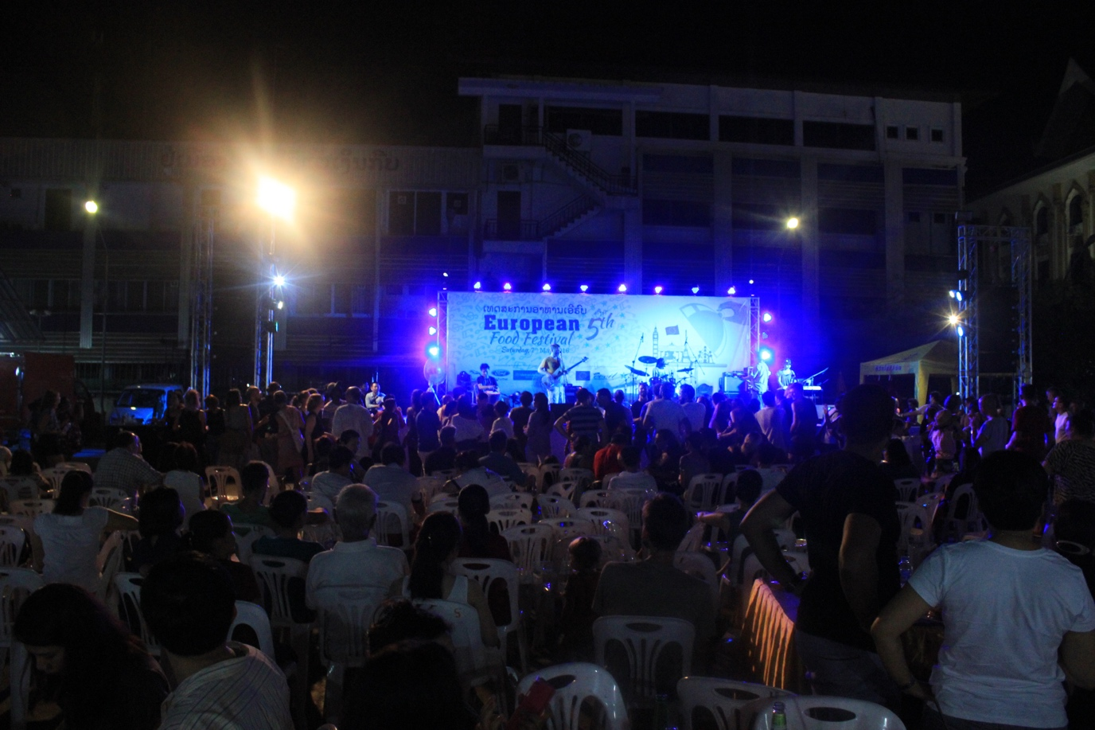

The bands were very well received with many of the audience, presumably those who still had room for more food and drink, getting up and moving to the beat.

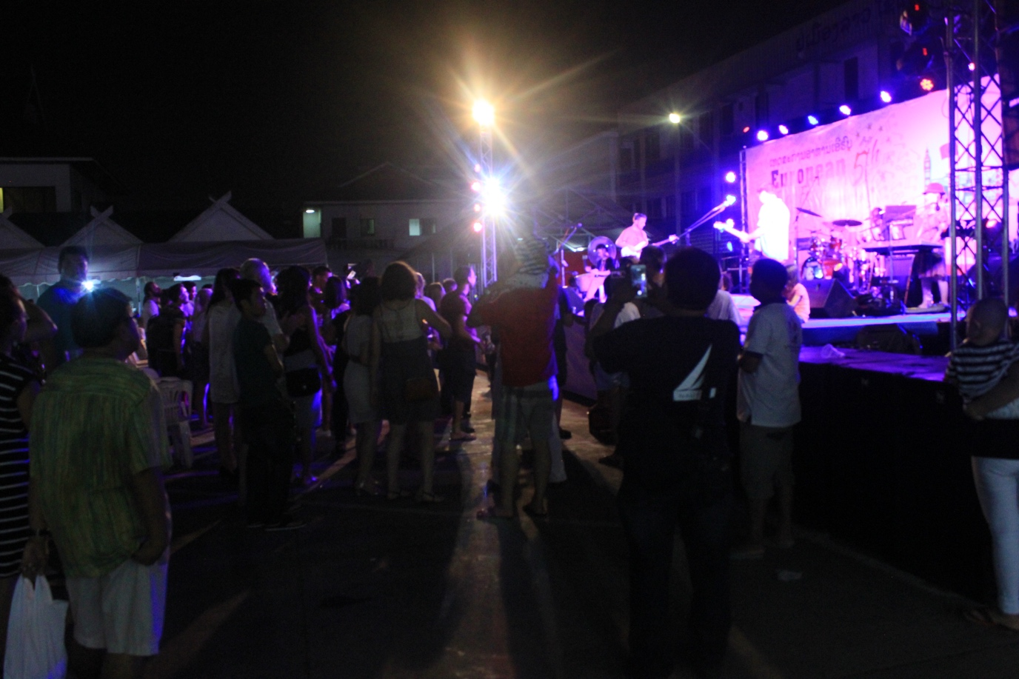

The live music was then followed by recorded music provided by 2 DJs, Benoit Dubeau and Antoine Bernasconi. During this period there was the lucky draw with prizes being provided by Vietnam Airlines, Sinouk Coffee, Sofitel Luang Prabang and Oh magazine. There was also a series of quick questions for the younger members of the audience with model aircraft from Vietnam Airlines being given away as prizes.

The music rounded out a most enjoyable day with everyone going home full and happy.

