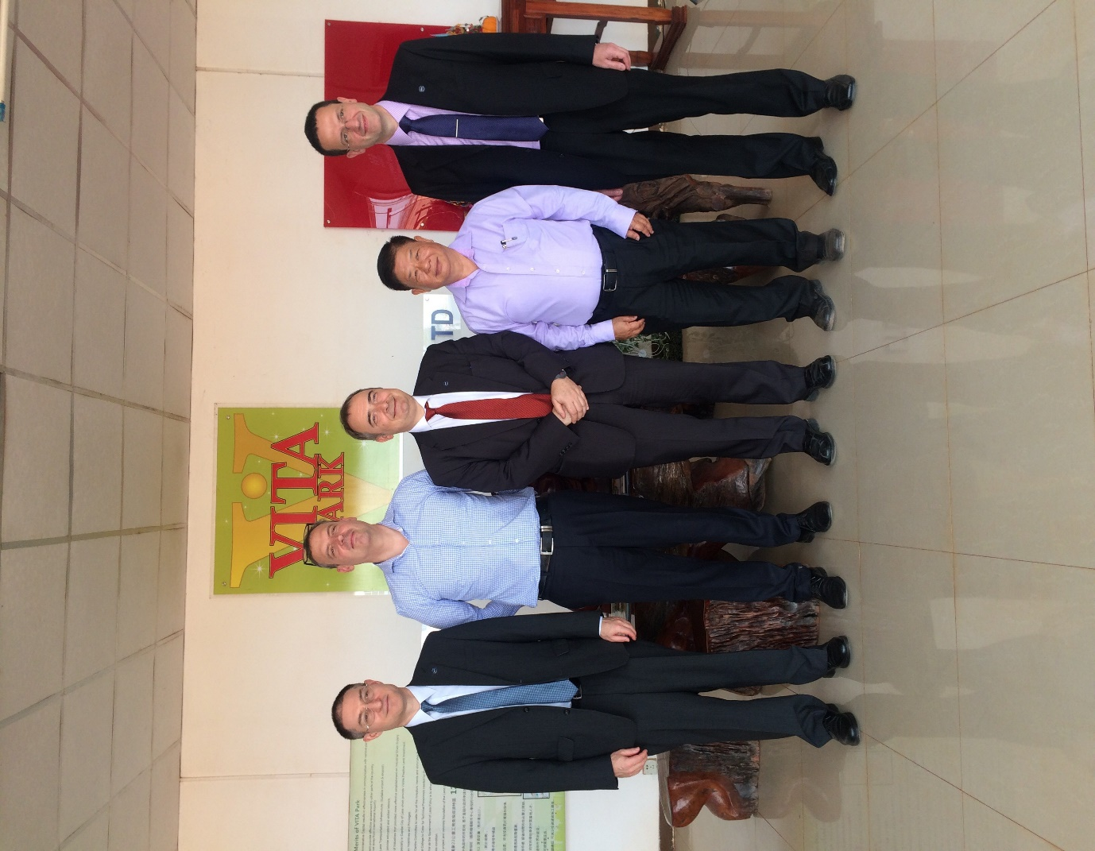
From left to right: Mr. Duncan Levine, ECCT Publications Editor, Mr. Philipp Glaeser, ECCIL Deputy Director Services & Events, Mr. Olivier Rousselet, ECCT Vice Chairman, Mr. Jensen Chen, Vientiane Industry & Trade Area Business Unit-CEO, Mr. Freddie Hoeglund ECCT CEO
At Vientiane Industry & Trade Area (Vita Park)

